Product Data Sheet
VSV-G-Tag Monoclonal Antibody
Catalog Number: ORF.VSVGMAB-50
Product Details
Product Name | VSV-G-Tag Monoclonal Antibody
Catalog Number | ORF.VSVGMAB-50
Size | 50 μL
Concentration | 1 mg/mL
Clonality | Monoclonal
Source | Mouse
Isotype | IgG
Purification | The antibody was purified by immunogen affinity chromatography.

Product Description |  | Product Image
The Vesicular Stomatitis Virus (VSV) G tag is derived from the glycoprotein of VSV, an enveloped RNA virus belonging to the Rhabdoviridae family. VSV G plays a critical role in viral assembly and budding from the plasma membrane of host cells. The commonly used VSV-G epitope tag corresponds to the sequence YTDIEMNRLGK, located in the extracellular membrane-proximal stem region of the glycoprotein, which is essential for efficient budding.  As a fusion tag, VSV-G enables convenient detection, localization, and characterization of recombinant proteins, especially when protein-specific antibodies are not available.  This monoclonal antibody specifically recognizes the VSV-G epitope and is optimized for Western blotting, providing sensitive and reliable detection of VSV-G–tagged proteins in research applications. |  | 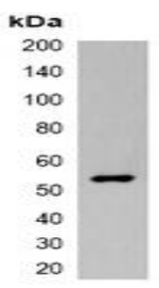
Product Specifications and Product Specific Information
Applications | WB: 1:2000 – 1:5000  IF/IC: 1:200 – 1:500  IP: 1:100 – 1:200
Reactivity | N/A
Specificity | Recognizes C-terminal, internal and N-terminal VSV-G-tag fusion proteins.
Immunogen | KLH-conjugated synthetic peptide encompassing a sequence of VSV-G-tag.  The exact sequence is proprietary.
Description | Mouse monoclonal antibody to VSV-G-tag
Buffer | Liquid in 0.42% Potassium phosphate, 0.87% Sodium chloride, pH 7.3, 30% glycerol, and 0.01% sodium azide.

Storage and Stability
 | Temperature | Storage Time
Short Term | 4°C | 1 month
Long Term | -20°C | 12 months
Avoid repeated freeze-thaw cycles.

Product Data
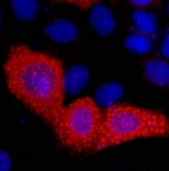

Immunofluorescent analysis of VSV-G-tag staining in 293T cells transfected with a VSV-G-tag protein. Formalin-fixed cells were permeabilized with 0.1% Triton X-100 in TBS for 5-10 minutes and blocked with 3% BSA-PBS for 30 minutes at room temperature. Cells were probed with the primary antibody in 3% BSA-PBS and incubated overnight. at 4 °C in a humidified chamber. Cells were washed with PBST and incubated with a DyLight 594-conjugated secondary antibody (red) in PBS at room temperature in the dark. DAPI was used to stain the cell nuclei (blue).

