Product Data Sheet
Rabbit Anti-Mouse IgG (H&L) HRP
Catalog Number: ORF.RBMSHRP-100
Product Details
Product Name | Rabbit Anti-Mouse IgG (H&L) HRP
Catalog Number | ORF.RBMSHRP-100
Size | 100 μL
Concentration | 1 mg/mL
Clonality | Polyclonal
Source | Rabbit
Isotype | IgG
Purification | The antibody was isolated from ascitic fluid by immunoaffinity chromatography using antigens coupled to agarose beads.

Product Description |  | Product Image
Rabbit Anti-Mouse IgG (H&L) HRP is an affinity-purified secondary antibody with well-characterized specificity for mouse immunoglobulins. It recognizes both heavy (H) and light (L) chains, ensuring broad detection of mouse IgG subclasses.  Secondary antibodies provide enhanced sensitivity through signal amplification, as multiple secondary antibodies can bind to a single primary antibody. Conjugation to horseradish peroxidase (HRP) enables reliable use in enzyme-based detection methods such as chemiluminescence and colorimetric assays.  This antibody is produced by immunizing rabbits with purified mouse immunoglobulins and further purified to ensure high specificity and minimal background reactivity. The HRP conjugation ensures sensitive and consistent performance in multiple applications including Western blotting. |  | 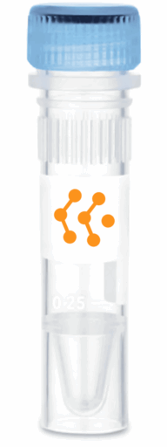
Product Specifications and Product Specific Information
Applications | ELISA: 1:5000 – 1:20000  WB: 1:5000 – 1:20000  IHC: 1:500 – 1:1000  ICC: 1:500 – 1:1000
Reactivity | Mouse
Specificity | By immunoelectrophoresis and ELISA this antibody reacts specifically with Mouse IgG. No antibody was detected against non immunoglobulin serum proteins.
Immunogen | Mouse IgG
Description | Rabbit Anti-Mouse IgG (H&L) conjugated to HRP
Buffer | Liquid in 0.01M Phosphate Buffered Saline, pH 7.2, containing 1% BSA, 50% glycerol, 0.05% Sodium Azide

Storage and Stability
 | Temperature | Storage Time
Short Term | 4°C | 1 month
Long Term | -20°C | 12 months
Avoid repeated freeze-thaw cycles.

Product Data
Coming Soon!

