Product Data Sheet
Rabbit Anti-Human IgG (H&L) HRP
Catalog Number: ORF.RBHUHRP-100
Product Details
Product Name | Rabbit Anti-Human IgG (H&L) HRP
Catalog Number | ORF.RBHUHRP-100
Size | 100 μL
Concentration | 1 mg/mL
Clonality | Polyclonal
Source | Rabbit
Isotype | IgG
Purification | The antibody was isolated from ascitic fluid by immunoaffinity chromatography using antigens coupled to agarose beads.

Product Description |  | Product Image
Rabbit Anti-Human IgG (H&L) HRP is an affinity-purified secondary antibody with well-defined specificity for human immunoglobulins. It binds to both heavy (H) and light (L) chains, ensuring broad detection of human IgG subclasses.  Secondary antibodies increase assay sensitivity through signal amplification, as multiple secondary antibodies can bind to a single primary antibody. Conjugation to horseradish peroxidase (HRP) enables robust detection in enzyme-based systems such as chemiluminescence and colorimetric assays.  This antibody is produced by immunizing rabbits with purified human immunoglobulins and subsequently affinity-purified to ensure high specificity and low background reactivity. The HRP conjugation ensures sensitive, consistent, and reproducible performance in multiple applications including Western blotting. |  | 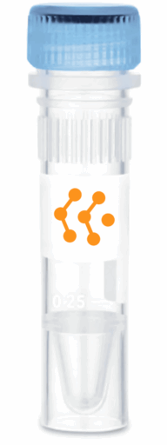
Product Specifications and Product Specific Information
Applications | ELISA: 1:5000 – 1:20000  WB: 1:5000 – 1:20000  IHC: 1:500 – 1:1000  ICC: 1:500 – 1:1000
Reactivity | Human
Specificity | By immunoelectrophoresis and ELISA this antibody reacts specifically with Human IgG. No antibody was detected against non immunoglobulin serum proteins.
Immunogen | Human IgG
Description | Rabbit Anti-Human IgG (H&L) conjugated to HRP
Buffer | Liquid in 0.01M Phosphate Buffered Saline, pH 7.2, containing 1% BSA, 50% glycerol, 0.05% Sodium Azide

Storage and Stability
 | Temperature | Storage Time
Short Term | 4°C | 1 month
Long Term | -20°C | 12 months
Avoid repeated freeze-thaw cycles.

Product Data
Coming Soon!

