Product Data Sheet
Myc-Tag Monoclonal Antibody
Catalog Number: ORF.MYCMAB-50
Product Details
Product Name | Myc-Tag Monoclonal Antibody
Catalog Number | ORF.MYCMAB-50
Size | 50 μL
Concentration | 1 mg/mL
Clonality | Monoclonal
Source | Mouse
Isotype | IgG
Purification | The antibody was purified by immunogen affinity chromatography.

Product Description |  | Product Image
The Myc tag is a short peptide sequence derived from the human c-Myc proto-oncogene product, a nuclear phosphoprotein involved in regulating cell cycle progression, apoptosis, and cellular transformation. In its native form, c-Myc functions by forming a heterodimer with the transcription factor MAX. This complex binds to the E-box DNA consensus sequence, controlling the transcription of specific target genes.  The Myc gene is frequently amplified in various human cancers, and chromosomal translocations involving this gene are linked to conditions such as Burkitt lymphoma and multiple myeloma. Notably, c-Myc translation can initiate from both an upstream non-AUG (CUG) codon and a downstream AUG start site, producing two isoforms with distinct N-terminal regions.  This monoclonal antibody specifically recognizes the Myc epitope, enabling reliable detection, localization, and purification of Myc-tagged recombinant proteins. It is ideal for applications including Western blotting, immunofluorescence, immunoprecipitation, and ELISA, offering high sensitivity and specificity for both native and denatured protein forms. |  | 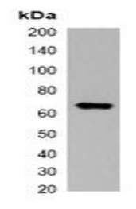
Product Specifications and Product Specific Information
Applications | WB: 1:2000 – 1:5000  IF/IC: 1:200 – 1:500  IP: 1:100 – 1:200
Reactivity | N/A
Specificity | Recognizes Myc-tag fusion proteins
Immunogen | KLH-conjugated synthetic peptide encompassing a sequence of Myc-tag.  The exact sequence is proprietary.
Description | Mouse monoclonal antibody to Myc-tag
Buffer | Liquid in 0.42% Potassium phosphate, 0.87% Sodium chloride, pH 7.3, 30% glycerol, and 0.01% sodium azide.

Storage and Stability
 | Temperature | Storage Time
Short Term | 4°C | 1 month
Long Term | -20°C | 12 months
Avoid repeated freeze-thaw cycles.

Product Data
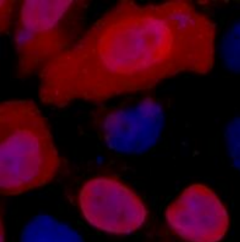

Immunofluorescent analysis of Myc-tag staining in 293T cells transfected with a Myc-tag protein. Formalin-fixed cells were permeabilized with 0.1% Triton X-100 in TBS for 5-10 minutes and blocked with 3% BSA-PBS for 30 minutes at room temperature. Cells were probed with the primary antibody in 3% BSA-PBS and incubated overnight. at 4 °C in a humidified chamber. Cells were washed with PBST and incubated with a DyLight 594-conjugated secondary antibody (red) in PBS at room temperature in the dark. DAPI was used to stain the cell nuclei (blue).

