Product Data Sheet
His-Tag Monoclonal Antibody
Catalog Number: ORF.HISMAB-50
Product Details
Product Name | His-Tag Monoclonal Antibody
Catalog Number | ORF.HISMAB-50
Size | 50 μL
Concentration | 1 mg/mL
Clonality | Monoclonal
Source | Mouse
Isotype | IgG
Purification | The antibody was purified by immunogen affinity chromatography.

Product Description |  | Product Image
The 6×His tag is a synthetic peptide consisting of six consecutive histidine residues (HHHHHH), typically engineered at either the N- or C-terminus of recombinant proteins. This tag enables efficient purification of tagged proteins through immobilized metal affinity chromatography (IMAC), leveraging the strong and selective binding of histidine clusters to metal ions such as Ni²⁺ or Co²⁺.  His-tagged proteins are widely used in recombinant protein production, where the histidine motif’s affinity for Ni²⁺–NTA resins allows purification to near homogeneity in a single chromatographic step. Beyond purification, the His tag facilitates detection, localization, and co-immunoprecipitation of recombinant proteins, particularly when protein-specific antibodies are unavailable.  This monoclonal antibody specifically recognizes the His epitope, providing high sensitivity and specificity in applications such as Western blotting, immunofluorescence, ELISA, and immunoprecipitation. It is suitable for detecting both native and denatured forms of His-tagged proteins, ensuring consistent and reliable results across diverse experimental systems. |  | 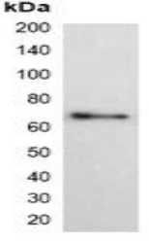
Product Specifications and Product Specific Information
Applications | WB: 1:1000 – 1:3000  IF/IC: 1:100 – 1:200  IP: 1:50 – 1:200
Reactivity | N/A
Specificity | Recognizes C-terminal, internal, and N-terminal His-tag fusion proteins
Immunogen | KLH-conjugated synthetic peptide encompassing a sequence of His-tag.  The exact sequence is proprietary.
Description | Mouse monoclonal antibody to His-tag
Buffer | Liquid in 0.42% Potassium phosphate, 0.87% Sodium chloride, pH 7.3, 30% glycerol, and 0.01% sodium azide.

Storage and Stability
 | Temperature | Storage Time
Short Term | 4°C | 1 month
Long Term | -20°C | 12 months
Avoid repeated freeze-thaw cycles.

Product Data
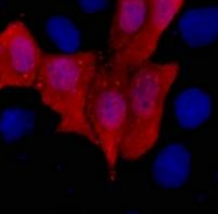

Immunofluorescent analysis of His-tag staining in 293T cells transfected with a His-tag protein. Formalin-fixed cells were permeabilized with 0.1% Triton X-100 in TBS for 5-10 minutes and blocked with 3% BSA-PBS for 30 minutes at room temperature. Cells were probed with the primary antibody in 3% BSA-PBS and incubated overnight. at 4 °C in a humidified chamber. Cells were washed with PBST and incubated with a DyLight 594-conjugated secondary antibody (red) in PBS at room temperature in the dark. DAPI was used to stain the cell nuclei (blue).

