Product Data Sheet
HA-Tag Monoclonal Antibody
Catalog Number: ORF.HAMAB-50
Product Details
Product Name | HA-Tag Monoclonal Antibody
Catalog Number | ORF.HAMAB-50
Size | 50 μL
Concentration | 1 mg/mL
Clonality | Monoclonal
Source | Mouse
Isotype | IgG
Purification | The antibody was purified by immunogen affinity chromatography.

Product Description |  | Product Image
The HA tag (hemagglutinin tag) is a short epitope sequence derived from the influenza virus hemagglutinin surface glycoprotein. It is widely used as a fusion tag to facilitate the detection, localization, and purification of recombinant proteins in various expression systems. When incorporated into a protein of interest, the HA tag enables:  - Protein Localization Studies – Tracking the distribution of tagged proteins within cells.  - Topology and Complex Analysis – Investigating protein structure, orientation, and interaction networks.  - Protein-Protein Interaction Mapping – Identifying associated proteins through co-immunoprecipitation.  - Characterization of Novel or Low-Abundance Proteins – Providing detection capability when specific antibodies are unavailable or the protein is poorly immunogenic.  This monoclonal antibody specifically recognizes the HA epitope and is ideal for applications such as Western blotting, immunofluorescence, immunoprecipitation, and ELISA. It offers high sensitivity and specificity for both native and denatured forms of HA-tagged proteins, ensuring reliable results in research and protein characterization workflows. |  | 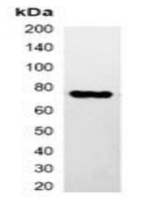
Product Specifications and Product Specific Information
Applications | WB: 1:2000 – 1:5000  IF/IC: 1:200 – 1:500  IP: 1:100 – 1:200
Reactivity | N/A
Specificity | Recognizes C-terminal, internal, and N-terminal HA-tag fusion proteins
Immunogen | KLH-conjugated synthetic peptide encompassing a sequence of HA-tag.  The exact sequence is proprietary.
Description | Mouse monoclonal antibody to HA-tag
Buffer | Liquid in 0.42% Potassium phosphate, 0.87% Sodium chloride, pH 7.3, 30% glycerol, and 0.01% sodium azide.

Storage and Stability
 | Temperature | Storage Time
Short Term | 4°C | 1 month
Long Term | -20°C | 12 months
Avoid repeated freeze-thaw cycles.

Product Data
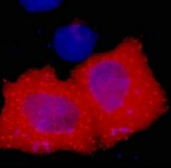
Immunofluorescent analysis of HA-tag staining in 293T cells transfected with an HA-tag protein. Formalin-fixed cells were permeabilized with 0.1% Triton X-100 in TBS for 5-10 minutes and blocked with 3% BSA-PBS for 30 minutes at room temperature. Cells were probed with the primary antibody in 3% BSA-PBS and incubated overnight. at 4 °C in a humidified chamber. Cells were washed with PBST and incubated with a DyLight 594-conjugated secondary antibody (red) in PBS at room temperature in the dark. DAPI was used to stain the cell nuclei (blue).

