Product Data Sheet
Goat Anti-Rabbit IgG (H&L) HRP
Catalog Number: ORF.GTRBHRP-100
Product Details
Product Name | Goat Anti-Rabbit IgG (H&L) HRP
Catalog Number | ORF.GTRBHRP-100
Size | 100 μL
Concentration | 1 mg/mL
Clonality | Polyclonal
Source | Goat
Isotype | IgG
Purification | The antibody was isolated from ascitic fluid by immunoaffinity chromatography using antigens coupled to agarose beads.

Product Description |  | Product Image
Goat Anti-Rabbit IgG (H&L) HRP is an affinity-purified secondary antibody with well-characterized specificity for rabbit immunoglobulins. It binds to both heavy (H) and light (L) chains, allowing broad detection of rabbit IgG subclasses.  Secondary antibodies enhance assay sensitivity by enabling signal amplification, as multiple secondary antibodies can bind to a single primary antibody. Conjugation to horseradish peroxidase (HRP) provides robust detection in enzyme-based systems, including chemiluminescence and colorimetric assays.  This antibody is generated by immunizing goats with purified rabbit immunoglobulins and further purified to ensure high specificity and minimal background. The HRP conjugation delivers consistent, sensitive, and reliable performance in multiple applications including Western blotting. |  | 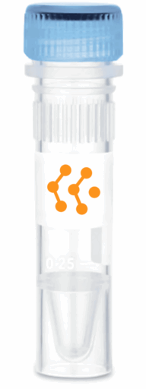
Product Specifications and Product Specific Information
Applications | ELISA: 1:5000 – 1:20000  WB: 1:5000 – 1:20000  IHC: 1:500 – 1:1000  ICC: 1:500 – 1:1000
Reactivity | Rabbit
Specificity | By immunoelectrophoresis and ELISA this antibody reacts specifically with Rabbit IgG. No antibody was detected against non immunoglobulin serum proteins.
Immunogen | Rabbit IgG
Description | Goat Anti-Rabbit IgG (H&L) conjugated to HRP
Buffer | Liquid in 0.01M Phosphate Buffered Saline, pH 7.2, containing 1% BSA, 50% glycerol, 0.05% Sodium Azide

Storage and Stability
 | Temperature | Storage Time
Short Term | 4°C | 1 month
Long Term | -20°C | 12 months
Avoid repeated freeze-thaw cycles.

Product Data
Coming Soon!

