Product Data Sheet
Goat Anti-Mouse IgG (H&L) HRP
Catalog Number: ORF.GTMSHRP-100
Product Details
Product Name | Goat Anti-Mouse IgG (H&L) HRP
Catalog Number | ORF.GTMSHRP-100
Size | 100 μL
Concentration | 1 mg/mL
Clonality | Polyclonal
Source | Goat
Isotype | IgG
Purification | The antibody was purified by immunoaffinity chromatography using antigens coupled to agarose beads.

Product Description |  | Product Image
Goat Anti-Mouse IgG (H&L) HRP is an affinity-purified secondary antibody with well-defined specificity for mouse immunoglobulins. It binds to both heavy (H) and light (L) chains, ensuring broad recognition of mouse IgG subclasses.  Secondary antibodies provide increased flexibility and sensitivity in detection systems by amplifying signal output—multiple secondary antibodies can bind to a single primary antibody. Conjugation to horseradish peroxidase (HRP) enables reliable use in enzyme-based detection methods such as chemiluminescence and colorimetric assays.  This antibody is generated by immunizing goats with purified mouse immunoglobulins and is further purified to ensure high specificity and low background. The HRP conjugation allows sensitive, consistent, and reproducible performance in applications such as Western blotting. |  | 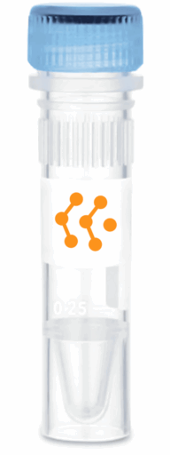
Product Specifications and Product Specific Information
Applications | ELISA: 1:5000 – 1:20000  WB: 1:2000 – 1:20000  IHC: 1:500 – 1:1000  ICC: 1:500 – 1:1000
Reactivity | Mouse
Specificity | By immunoelectrophoresis and ELISA this antibody reacts specifically with Mouse IgG. No antibody was detected against non immunoglobulin serum proteins.
Immunogen | Mouse IgG
Description | Goat Anti-Mouse IgG (H&L) conjugated to HRP
Buffer | Liquid in 0.01M Phosphate Buffered Saline, pH 7.2, containing 1% BSA, 50% glycerol, 0.05% Sodium Azide

Storage and Stability
 | Temperature | Storage Time
Short Term | 4°C | 1 month
Long Term | -20°C | 12 months
Avoid repeated freeze-thaw cycles.

Product Data
Coming Soon!

