Product Data Sheet
Goat Anti-Human IgG (H&L) HRP
Catalog Number: ORF.GTHUHRP-100
Product Details
Product Name | Goat Anti-Human IgG (H&L) HRP
Catalog Number | ORF.GTHUHRP-100
Size | 100 μL
Concentration | 1 mg/mL
Clonality | Polyclonal
Source | Goat
Isotype | IgG
Purification | The antibody was isolated from ascitic fluid by chromatography using antigens coupled to agarose beads.

Product Description |  | Product Image
Goat Anti-Human IgG (H&L) HRP is an affinity-purified secondary antibody with well-characterized specificity for human immunoglobulins. It recognizes both heavy (H) and light (L) chains, ensuring broad detection of human IgG subclasses.  Secondary antibodies provide enhanced sensitivity and versatility by amplifying signal output—multiple secondaries can bind to a single primary antibody. Conjugation to horseradish peroxidase (HRP) enables robust performance in enzyme-based detection methods, including chemiluminescence and colorimetric assays.  This antibody is produced by immunizing goats with purified human immunoglobulins and further purified to achieve high specificity and low background reactivity. The HRP conjugation ensures consistent and sensitive detection in applications such as ELISA and western blotting. |  | 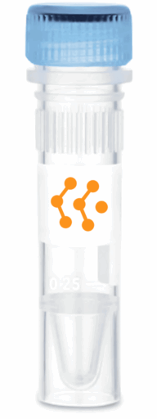
Product Specifications and Product Specific Information
Applications | ELISA: 1:5000 – 1:20000  WB: 1:5000 – 1:20000  IHC: 1:500 – 1:1000  ICC: 1:500 – 1:1000
Reactivity | Human
Specificity | By immunoelectrophoresis and ELISA this antibody reacts specifically with Human IgG. No antibody was detected against non immunoglobulin serum proteins.
Immunogen | Human IgG
Description | Goat Anti-Human IgG (H&L) conjugated to HRP
Buffer | Liquid in 0.01M Phosphate Buffered Saline, pH 7.2, containing 1% BSA, 50% glycerol, 0.05% Sodium Azide

Storage and Stability
 | Temperature | Storage Time
Short Term | 4°C | 1 month
Long Term | -20°C | 12 months
Avoid repeated freeze-thaw cycles.

Product Data
Coming Soon!

