Product Data Sheet
GST-Tag Monoclonal Antibody
Catalog Number: ORF.GSTMAB-50
Product Details
Product Name | GST-Tag Monoclonal Antibody
Catalog Number | ORF.GSTMAB-50
Size | 50 μL
Concentration | 1 mg/mL
Clonality | Monoclonal
Source | Mouse
Isotype | IgG
Purification | The antibody was purified by immunogen affinity chromatography.

Product Description |  | Product Image
Glutathione S-transferase (GST) is a 26 kDa protein found in both eukaryotic and prokaryotic organisms, where it catalyzes a variety of biochemical reactions. In research applications, the GST gene is frequently used in fusion expression systems, producing GST-tagged proteins that can be efficiently purified via their strong affinity for glutathione.  GST fusion proteins are widely utilized in protein research, particularly for studying direct protein–protein interactions. The GST tag system is compatible with numerous expression vectors, making it a versatile and widely adopted tool for recombinant protein production and purification.  This monoclonal antibody specifically recognizes the GST epitope, enabling sensitive and specific detection of GST-tagged proteins in applications such as Western blotting, immunoprecipitation, immunofluorescence, and ELISA. It provides reliable performance for both native and denatured forms, ensuring consistent results across diverse experimental workflows. |  | 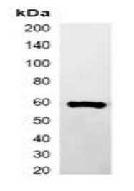
Product Specifications and Product Specific Information
Applications | WB: 1:2000 – 1:5000  IP: 1:100 – 1:200
Reactivity | N/A
Specificity | Recognizes C-terminal, internal, and N-terminal GST-tag fusion proteins
Immunogen | KLH-conjugated synthetic peptide encompassing a sequence of GST-tag.  The exact sequence is proprietary.
Description | Mouse monoclonal antibody to GST-tag
Buffer | Liquid in 0.42% Potassium phosphate, 0.87% Sodium chloride, pH 7.3, 30% glycerol, and 0.01% sodium azide.

Storage and Stability
 | Temperature | Storage Time
Short Term | 4°C | 1 month
Long Term | -20°C | 12 months
Avoid repeated freeze-thaw cycles.

Product Data
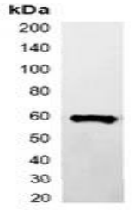

Western blot analysis of over-expressed GST-tagged protein in 293T cell lysate.

