Product Data Sheet
Flag-Tag Monoclonal Antibody
Catalog Number: ORF.FLAGMAB-50
Product Details
Product Name | Flag-Tag Monoclonal Antibody
Catalog Number | ORF.FLAGMAB-50
Size | 50 μL
Concentration | 1 mg/mL
Clonality | Monoclonal
Source | Mouse
Isotype | IgG
Purification | The antibody was purified by immunogen affinity chromatography.

Product Description |  | Product Image
The DYKDDDDK tag, also known as the FLAG® tag, is an eight–amino acid epitope sequence (Asp–Tyr–Lys–Asp–Asp–Asp–Asp–Lys) used to facilitate protein purification, detection, and localization. It can be fused to either the N- or C-terminus of a target protein and enables efficient isolation and identification using anti-FLAG antibodies.  Optimized for compatibility, the FLAG tag is highly hydrophilic, minimizing the risk of protein denaturation or loss of activity upon tagging. Its versatility makes it widely applicable in protein-protein interaction studies, protein expression analysis, and cellular localization assays. |  | 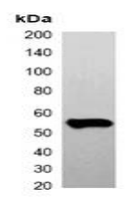
Product Specifications and Product Specific Information
Applications | WB: 1:2000 – 1:5000  IF/IC: 1:200 – 1:500  IP: 1:100 – 1:200
Reactivity | N/A
Specificity | Recognizes C-terminal, internal, and N-terminal FLAG-tag fusion proteins
Immunogen | KLH-conjugated synthetic peptide encompassing a sequence of FLAG-tag.  The exact sequence is proprietary.
Description | Mouse monoclonal antibody to FLAG-tag
Buffer | Liquid in 0.42% Potassium phosphate, 0.87% Sodium chloride, pH 7.3, 30% glycerol, and 0.01% sodium azide.

Storage and Stability
 | Temperature | Storage Time
Short Term | 4°C | 1 month
Long Term | -20°C | 12 months
Avoid repeated freeze-thaw cycles.

Product Data
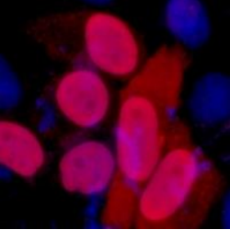
Immunofluorescent analysis of FLAG-tag staining in 293T cells transfected with a Flag-tag protein. Formalin-fixed cells were permeabilized with 0.1% Triton X-100 in TBS for 5-10 minutes and blocked with 3% BSA-PBS for 30 minutes at room temperature. Cells were probed with the primary antibody in 3% BSA-PBS and incubated overnight. at 4 °C in a humidified chamber. Cells were washed with PBST and incubated with a DyLight 594-conjugated secondary antibody (red) in PBS at room temperature in the dark. DAPI was used to stain the cell nuclei (blue).

