Product Information Sheet
CHO-Adhere Growth Medium
Catalog Numbers: ORF.CHOAD-450, ORF.CHOAD-900
Product Overview
Product Name | CHO-Adhere Growth Media
Catalog Numbers | ORF.CHOAD-450, ORF.CHOAD-900
Sizes | 450 mL, 900 mL
Product Form | Liquid
Companion Cell Type | Chinese Hamster Ovary (CHO) K-1 Cells
Additional Reagents Required | High grade or fully defined Fetal Bovine Serum (FBS)  Penicillin/Streptomycin/Amphotericin B solution or Penicillin/Streptomycin solution

Product Description |  | Product Image
CHO-Adhere Growth Medium is a high-performance formulation specifically optimized for the robust growth and expansion of adherent Chinese Hamster Ovary (CHO) cells. This versatile medium supports reliable cell attachment and proliferation while maintaining high viability and consistent expression profiles across multiple passages.  CHO-Adhere Growth Medium promotes high-density monolayer cultures with minimal cellular stress. Its transfection-compatible formulation enables efficient gene delivery, making it well-suited for applications in gene expression studies, recombinant protein production, and early-stage biopharmaceutical development workflows. |  | 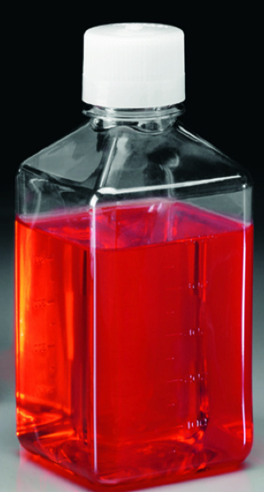
Media Formulation Protocol
Defrosting/Preparation | Thaw 50 mL for ORF.CHOAD-450 or 100 mL for ORF.CHOAD-900 of Fetal Bovine Serum (FBS) (not included) and 5 mL for ORF.CHOAD-450 or 10 mL for ORF.CHOAD-900 of antibiotic-antimycotic solution (not included) in a 37°C water bath until no visible ice remains. Immediately disinfect the exterior of the tubes and the base medium bottle using 70% isopropanol before proceeding to aseptic handling.
Mixing | Working under sterile conditions in a laminar flow hood, aseptically remove and discard 5 mL of ORF.CHOAD-450 or 10 mL of ORF.CHOAD-900 base medium from the bottle to accommodate supplement additions. Add 50 mL for ORF.CHOAD-450 or 100 mL for ORF.CHOAD-900 of thawed Fetal Bovine Serum (FBS), followed by 5 mL for ORF.CHOAD-450 or 10 mL for ORF.CHOAD-900 of antibiotic-antimycotic solution, to the remaining base medium. Replace the cap securely and gently swirl the bottle to ensure thorough mixing. The medium is now fully supplemented and ready for use in cell culture applications.

Cell Thawing and Plating Protocol for CHO K-1 Cells (not included)
Thawing | To thaw CHO-K1 cells (ORF.CHOK1-500), remove the vial from dry ice or liquid nitrogen storage and promptly place it in a 37°C water bath. Gently agitate the vial continuously while monitoring for thawing. As soon as only a small amount of ice remains, remove the vial from the bath to prevent over-thawing, which can compromise cell viability. Immediately disinfect the outside of the vial using 70% isopropanol before proceeding to the next step.
Plating | Working under sterile conditions in a laminar flow hood, carefully open the vial and transfer the contents to a sterile 15 mL conical tube. Slowly add approximately 9 mL of supplemented CHO-Adhere Growth Medium, pre-warmed to 37°C, to the cell suspension. Centrifuge the tube at 200 × g for 10 minutes to pellet the cells. After centrifugation, discard the supernatant and gently resuspend the pellet in an appropriate volume of fresh, pre-warmed supplemented CHO-Adhere Growth Medium to achieve a plating density of 20,000 cells per cm² of surface area. Transfer the resuspended cells into a suitable culture flask or dish. After 24 hours, aspirate the medium, and replace with fresh, pre-warmed supplemented CHO-Adhere Growth Medium.
Observation and Expansion | Following thawing, it is normal for CHO-K1 cells to grow slowly during the first week. Some cell loss may occur during initial medium exchanges, which is expected. Once the culture reaches approximately 70–80% confluence, the cells should be sub-cultured using a 1:3 split ratio. For passaging, use 0.25% Trypsin-EDTA solution (not included), following standard cell culture protocols.

Storage and Stability
 | Storage Temperature | Storage Time
CHO-Adhere Growth Medium (Base Media) (ORF.CHOAD-450, ORF.CHOAD-900) | 2-8°C | 3 months
Supplemented CHO-Adhere Growth Media | 2-8°C | Up to 3 weeks
Companion CHO K-1 Cells (ORF.CHOK1-500) | Liquid Nitrogen | 12 months
Avoid repeated freeze-thaw cycles for cells. Avoid repeated exposure to room temperature and light for media.

