Product Information Sheet
Human Embryonic Kidney 293 (HEK 293) Cells
Catalog Numbers: ORF.HEK293-500
Product Overview
Product Name | Human Embryonic Kidney 293 (HEK 293) Cells
Catalog Numbers | ORF.HEK293-500
Sizes | ≥500,000 cells/vial
Product Form | Cryopreserved (Frozen)
Cell Type | Human Embryonic Kidney Epithelial Cells
Additional Reagents Required | HEK-Adhere Growth Medium

Product Description | Product Image
HEK 293 cells are a widely used human epithelial cell line derived from embryonic kidney tissue. Originally developed by transformation with adenovirus type 5 DNA, HEK 293 cells are highly versatile and have become a foundational tool in molecular and cellular biology research. They exhibit rapid growth, strong adherence, and exceptional transfection efficiency, making them ideal for a broad range of applications in gene expression studies, viral vector production, and recombinant protein production and biotherapeutic development.  HEK 293 cells are maintained as adherent cultures under standard conditions and demonstrate reliable performance in transient and stable transfection workflows. Their well-characterized genomic profile, high protein expression capacity, and robust viability across passages support reproducibility in experimental and production-scale processes. | 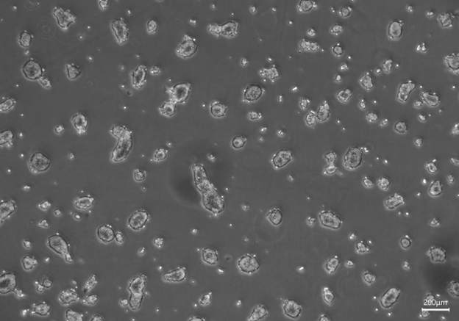

Cell Characteristics
Growth Characteristics | Adherent monolayer under standard culture conditions
Cell Origin | Human Embryonic Kidney (Homo sapiens)

Cell Thawing and Plating Protocol
Thawing | To thaw HEK 293 cells, remove the vial from dry ice or liquid nitrogen storage and promptly place it in a 37°C water bath. Gently agitate the vial continuously while monitoring for thawing. As soon as only a small amount of ice remains, remove the vial from the bath to prevent over-thawing, which can compromise cell viability. Immediately disinfect the outside of the vial using 70% isopropanol before proceeding to the next step.
Plating | Working under sterile conditions in a laminar flow hood, carefully open the vial and transfer the contents to a sterile 15 mL conical tube. Slowly add approximately 9 mL of supplemented HEK-Adhere Growth Medium, pre-warmed to 37°C, to the cell suspension. Centrifuge the tube at 200 × g for 10 minutes to pellet the cells. After centrifugation, discard the supernatant and gently resuspend the pellet in an appropriate volume of fresh, pre-warmed supplemented HEK-Adhere Growth Medium to achieve a plating density of 20,000 cells per cm² of surface area. Transfer the resuspended cells into a suitable culture flask or dish. After 24 hours, aspirate the medium, and replace with fresh, pre-warmed supplemented HEK-Adhere Growth Medium.
Observation and Expansion | Following thawing, it is normal for HEK 293 cells to grow slowly during the first week. Some cell loss may occur during initial medium exchanges, which is expected. Once the culture reaches approximately 70–80% confluence, the cells should be sub-cultured using a 1:3 split ratio. For passaging, use 0.25% Trypsin-EDTA solution (not included), following standard cell culture protocols.

Storage and Stability
 | Storage Temperature | Storage Time
HEK 293 Cells (ORF.HEK293-500) | Liquid Nitrogen | 12 months
HEK-Adhere Growth Media (Base Media) (ORF.HEKAD-450, ORF.HEKAD-900) | 2-8°C | 3 months
Supplemented HEK-Adhere Growth Medium | 2-8°C | Up to 3 weeks
Avoid repeated freeze-thaw cycles for cells. Avoid repeated exposure to room temperature and light for media.

