Product Information Sheet
Chinese Hamster Ovary, K1 (CHO-K1) Cells
Catalog Numbers: ORF.CHOK1-500
Product Overview
Product Name | Chinese Hamster Ovary, K1 (CHO-K1) Cells
Catalog Numbers | ORF.CHOK1-500
Sizes | ≥500,000 cells/vial
Product Form | Cryopreserved (Frozen)
Cell Type | Chinese Hamster Ovary Epithelial Cells
Additional Reagents Required | CHO-Adhere Growth Medium

Product Description | Product Image
CHO-K1 cells are a widely used mammalian cell line derived from the ovary of the Chinese hamster (Cricetulus griseus). These adherent epithelial cells are a workhorse for biopharmaceutical manufacturing, recombinant protein expression, and DNA studies due to their robust growth, adaptability to various culture conditions, and stable transfection efficiency.  Applications for CHO-K1 cells include:  Therapeutic protein production  Gene editing experiments  Receptor-ligand interaction studies  Glycosylation profiling of recombinant proteins  They display reliable adherence characteristics, a well-documented genetic profile, and have been optimized for high viability and consistent growth. | 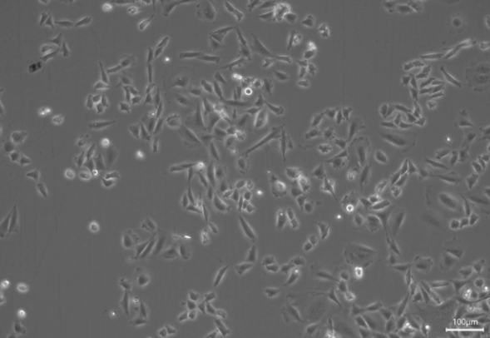

Cell Characteristics
Growth Characteristics | Adherent monolayer under standard culture conditions
Cell Origin | Chinese hamster (Cricetulus griseus)

Cell Thawing and Plating Protocol
Thawing | To thaw CHO-K1 cells, remove the vial from dry ice or liquid nitrogen storage and promptly place it in a 37°C water bath. Gently agitate the vial continuously while monitoring for thawing. As soon as only a small amount of ice remains, remove the vial from the bath to prevent over-thawing, which can compromise cell viability. Immediately disinfect the outside of the vial using 70% isopropanol before proceeding to the next step.
Plating | Working under sterile conditions in a laminar flow hood, carefully open the vial and transfer the contents to a sterile 15 mL conical tube. Slowly add approximately 9 mL of supplemented CHO-Adhere Growth Medium, pre-warmed to 37°C, to the cell suspension. Centrifuge the tube at 200 × g for 10 minutes to pellet the cells. After centrifugation, discard the supernatant and gently resuspend the pellet in an appropriate volume of fresh, pre-warmed supplemented CHO-Adhere Growth Medium to achieve a plating density of 20,000 cells per cm² of surface area. Transfer the resuspended cells into a suitable culture flask or dish. After 24 hours, aspirate the medium, and replace with fresh, pre-warmed supplemented CHO-Adhere Growth Medium.
Observation and Expansion | Following thawing, it is normal for CHO-K1 cells to grow slowly during the first week. Some cell loss may occur during initial medium exchanges, which is expected. Once the culture reaches approximately 70–80% confluence, the cells should be sub-cultured using a 1:3 split ratio. For passaging, use 0.25% Trypsin-EDTA solution (not included), following standard cell culture protocols.

Storage and Stability
 | Storage Temperature | Storage Time
CHO-K1 Cells (ORF.CHOK1-500) | Liquid Nitrogen | 12 months
CHO-Adhere Growth Media (Base Media) (ORF.CHOAD-450, ORF.CHOAD-900) | 2-8°C | 3 months
Supplemented CHO-Adhere Growth Medium | 2-8°C | Up to 3 weeks
Avoid repeated freeze-thaw cycles for cells. Avoid repeated exposure to room temperature and light for media.

